**Artifacts from the Ancient World, Middle Ages, and the Renaissance**

*My beliefs on why they were created and why the creators felt the need to express themselves using these artifacts*.

1. **The Ancient World**

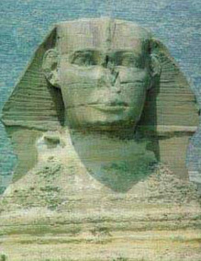<http://www.touregypt.net/images/touregypt/khafre3.jpg>

The Great Sphinx was originally designed the commemorate the god of the sun “Re”. However, the face was re-sculpted to resemble the pharaoh Khafre. I believe that the creator did this as “re” was in the title of the pharaoh Khafre and hence the depiction of him as being the god of the sun. I believe the expression of this was towards his respect to the pharaoh.

1. **The Middle Ages-**

<https://www.ancient.eu/img/r/p/500x600/13180.jpg.avif?v=1607860804>

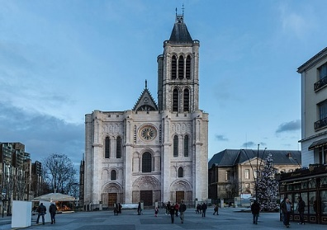 I believe Gothic Cathedrals were created to get more people involved in church. They were very high buildings that looking up at them looked as if they were going towards the heavens. There were engravings on the doors and other parts of the buildings of scriptures from the bible and stained-glass that was to bring in “divine light” into the cathedral. I think in a time where Christianity was law, this was to get more people to know right from wrong in the ways of Christianity.

1. **The Renaissance-**

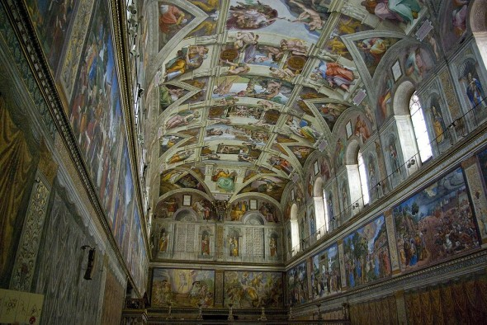<http://www.italianrenaissance.org/wp-content/uploads/2013/05/Michelangelo-Sistine-Chapel-Ceiling-590x394.jpg>

Michelangelo’s painting of the Sistine Chapel’s ceiling in the Vatican. I believe this was created to have a visual of the old testament from the bible and I believe he did this as a task from god. Also, I think he wanted to show his capability of what he can do and his devotion with this as something that took years to accomplish.

**Citations**

**1.)** Dunn, J. Khafre, the 4th King of Egypt's 4th Dynasty. Tour Egypt. http://www.touregypt.net/featurestories/khafre.htm

2.) Smith, H. (2020, December 8). Gothic Cathedrals: Architecture & Divine Light. World History Encyclopedia. https://www.ancient.eu/article/1649/gothic-cathedrals-architecture--divine-light/

3.) http://www.italianrenaissance.org/a-closer-look-michelangelos-painting-of-the-sistine-chapel-ceiling/